Secure Research Lab

Introduction:
This secure lab showcases the important security protocols for connecting different networks. The lab’s main focus is security and strict access controls. This lab implements WPA2 personal with AES, firewall, SSH, rate limiting, VLAN segmentation, IP-MAC Binding.

Topology:-

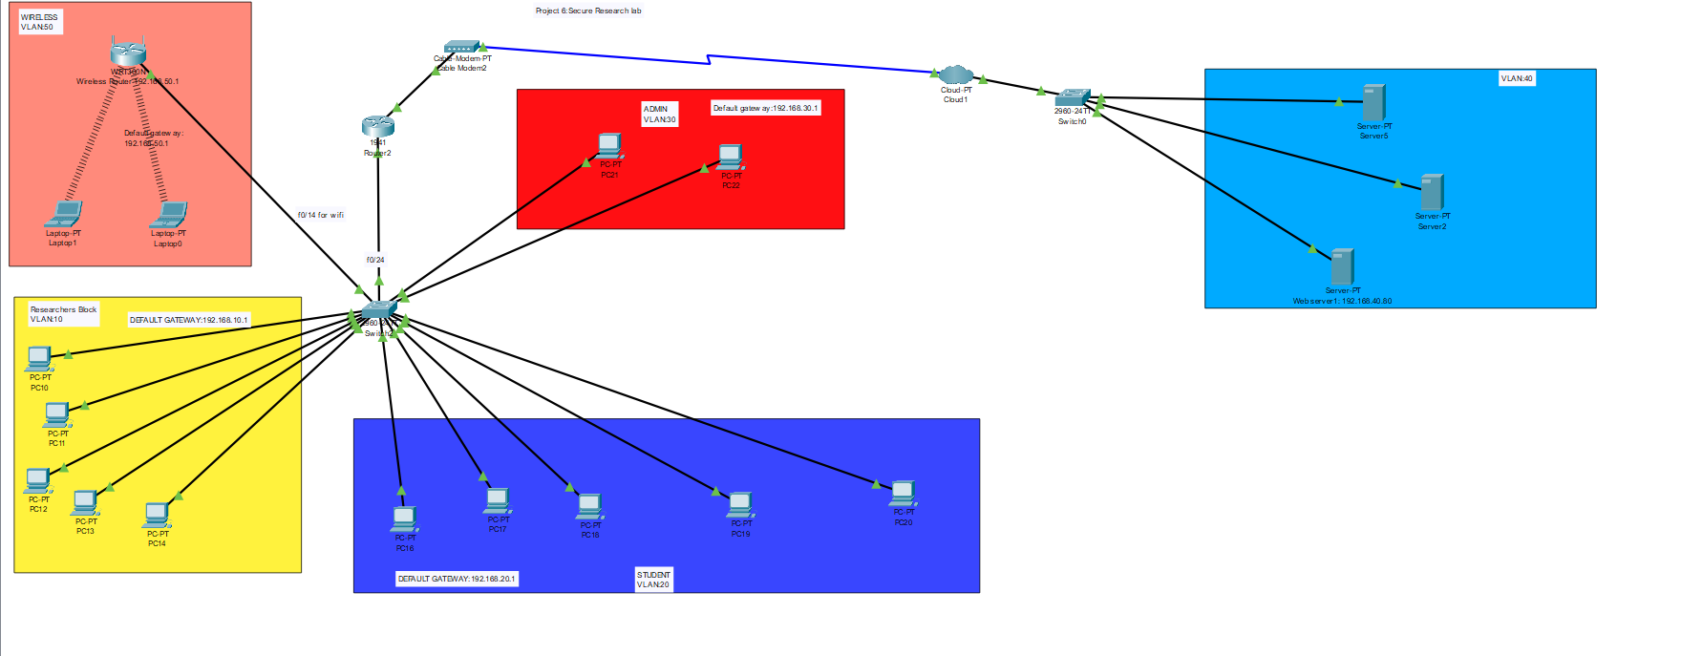
Devices Used:-
- 12 PC
- 2 Switch
- 1 Router
- 3 Server
- 2 Laptops
- 1 Wireless
- 1 ISP
- 1 Cable Modem

Researcher block:-
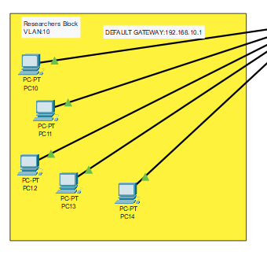
This block have 5 pcs and uses IP-MAC binding. It uses RIP routing protocol.
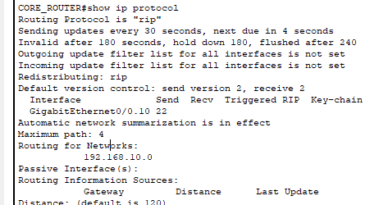
Student block:-
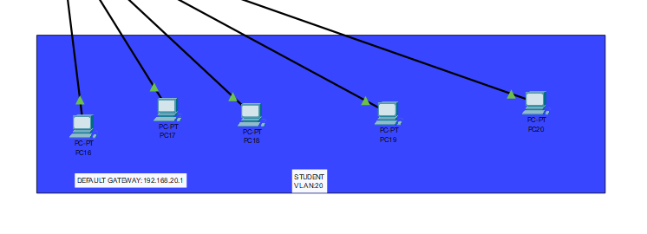
This block have 5 pcs that uses VLAN segmentation and rate limiting.

Admin block:-
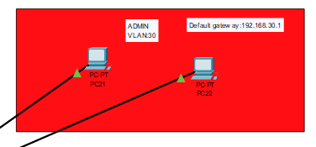

This block have 2 PCs and can only be accessed by SSH. This block uses OSPF routing protocol.
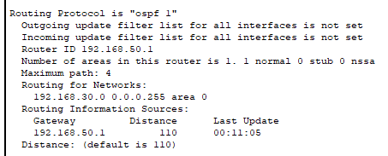

Wireless zone:-
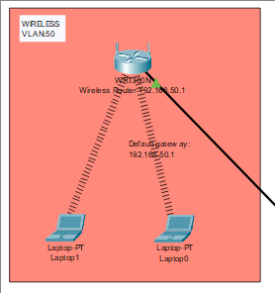
This block of lab have 2 laptops and 1 wireless router that use WPA2 personal for authentication.

Servers block:-
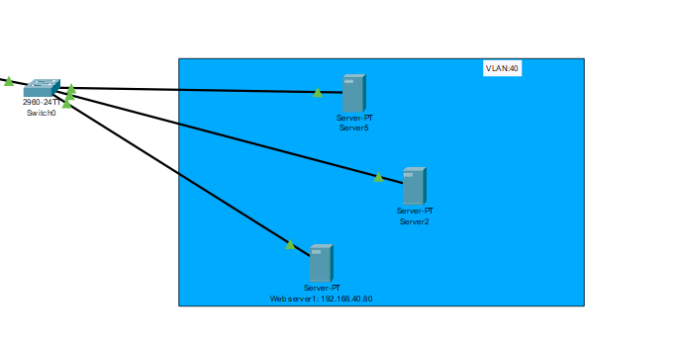
It have 3 servers.

Outcomes:-
- We can ping researchers pc from student pc.

- Wireless zone is strictly authenticated by WPA2 Personal with AES encryption.
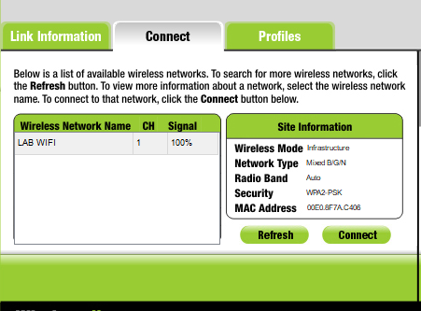

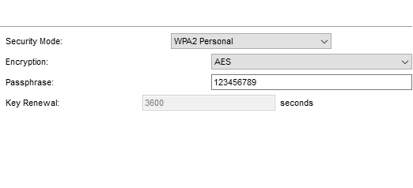
- Admin block PCs can only be accessed by SSH.

